Module 8) Bootstrap Basic & Advanced

**Q-1   What are the advantages of Bootstrap?**

**Ans.**

1. **Bootstrap is Easy to Use** =  Bootstrap is very easy and quite simple to use for designing and development. Being a new framework there is a lot to learn from it. It can be used with CSS, LESS or SasS etc.
2. **Fast and Time-Saving Framework** = Bootstrap is an agile framework which is quite faster than other frameworks. It saves time due to its standard ready-made coding blocks, responsiveness, and cross-browser capabilities.
3. **Bootstrap is totally Customizable** = It is developer friendly and can be customized as per the project requirements.
4. **Cross-browser compatibility =** Every user is different, and so is their device. Along with the device, they use varied browsers too. Bootstrap is compatible with the latest versions of all modern browsers and platforms.
5. **JavaScript plugins to your rescue** = To make the pages more interactive, one needs elements, like sliders, drop-down menus, tabs, etc.

**Q-2  What is a Bootstrap Container, and how does it work?**

**Ans.**

In Bootstrap, a container is used to set the content's margins dealing with the responsive behaviors of your layout. It contains the row elements and the row elements are the container of columns (known as grid system).

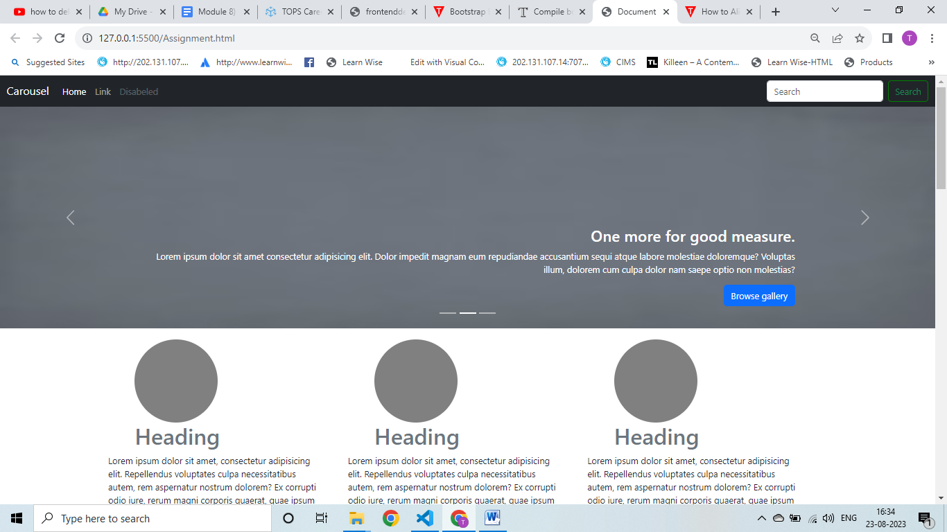

<!DOCTYPE html>

<html lang="en">

<head>

    <meta charset="UTF-8">

    <meta name="viewport" content="width=device-width, initial-scale=1.0">

    <title>Document</title>

    <!-- link bootstrap -->

    <link href="https://cdn.jsdelivr.net/npm/bootstrap@5.3.1/dist/css/bootstrap.min.css" rel="stylesheet"

        integrity="sha384-4bw+/aepP/YC94hEpVNVgiZdgIC5+VKNBQNGCHeKRQN+PtmoHDEXuppvnDJzQIu9" crossorigin="anonymous">

    <style>

        * {

            margin: 0;

            padding: 0;

            box-sizing: border-box;

        }

        .head {

            height: 150px;

            width: 150px;

            border-radius: 50%;

            background-color: gray;

            margin-top: 20px;

        }

        @media screen and (max-width:767px) {

            .header {

                flex-wrap: wrap;

            }

            .back-up {

                margin-right: 100px;

            }

        }

        @media screen and (max-width:1020px) {

            img {

                width: -webkit-fill-available;

                vertical-align: middle;

            }

        }

        .right-header {

            margin-top: 150px;

        }

    </style>

</head>

<body>

    <!-- navbar start -->

    <nav class="navbar navbar-expand-sm navbar-dark bg-dark">

        <div class="container-fluid">

            <a class="navbar-brand" href="javascript:void(0)">Carousel</a>

            <button class="navbar-toggler" type="button" data-bs-toggle="collapse" data-bs-target="#mynavbar">

                <span class="navbar-toggler-icon"></span>

            </button>

            <div class="collapse navbar-collapse" id="mynavbar">

                <ul class="navbar-nav me-auto">

                    <li class="nav-item">

                        <a class="nav-link active" href="javascript:void(0)">Home</a>

                    </li>

                    <li class="nav-item">

                        <a class="nav-link link" href="javascript:void(0)">Link</a>

                    </li>

                    <li class="nav-item">

                        <a class="nav-link disabled" href="javascript:void(0)">Disabeled</a>

                    </li>

                </ul>

                <form class="d-flex">

                    <input class="form-control me-2" type="text" placeholder="Search">

                    <button type="button" class="btn text-success" style="border: 2px solid green;">Search</button>

                </form>

            </div>

        </div>

    </nav>

    <!-- navbar end -->

    <!-- Carousel start-->

    <div id="demo" class="carousel slide" data-bs-ride="carousel">

        <!-- Indicators/dots -->

        <div class="carousel-indicators">

            <button type="button" data-bs-target="#demo" data-bs-slide-to="0" class="active"></button>

            <button type="button" data-bs-target="#demo" data-bs-slide-to="1"></button>

            <button type="button" data-bs-target="#demo" data-bs-slide-to="2"></button>

        </div>

        <!-- The slideshow/carousel -->

        <div class="carousel-inner">

            <div class="carousel-item active">

                <img src="https://img.freepik.com/free-photo/gray-smooth-textured-paper-background_53876-101833.jpg?size=626&ext=jpg&ga=GA1.2.2058622383.1691672536&semt=ais"

                    alt="Chicago" class="d-block" style="width:100%" height="400px">

                <div class="carousel-caption">

                    <h3 class="text-end">One more for good measure.</h3>

                    <p class="text-end">Lorem ipsum dolor sit amet consectetur adipisicing elit. Dolor impedit magnam

                        eum

                        repudiandae accusantium sequi atque labore molestiae doloremque? Voluptas illum, dolorem cum

                        culpa dolor nam saepe optio non molestias?</p>

                    <button class="btn btn-primary float-end" type="button">Browse gallery</button>

                </div>

            </div>

            <div class="carousel-item">

                <img src="https://img.freepik.com/free-photo/gray-smooth-textured-paper-background_53876-101833.jpg?size=626&ext=jpg&ga=GA1.2.2058622383.1691672536&semt=ais"

                    alt="Chicago" class="d-block" style="width:100%" height="400px">

                <div class="carousel-caption">

                    <h3 class="text-end">One more for good measure.</h3>

                    <p class="text-end">Lorem ipsum dolor sit amet consectetur adipisicing elit. Dolor impedit magnam

                        eum

                        repudiandae accusantium sequi atque labore molestiae doloremque? Voluptas illum, dolorem cum

                        culpa dolor nam saepe optio non molestias?</p>

                    <button class="btn btn-primary float-end" type="button">Browse gallery</button>

                </div>

            </div>

            <div class="carousel-item">

                <img src="https://img.freepik.com/free-photo/gray-smooth-textured-paper-background_53876-101833.jpg?size=626&ext=jpg&ga=GA1.2.2058622383.1691672536&semt=ais"

                    alt="Chicago" class="d-block" style="width:100%" height="400px">

                <div class="carousel-caption">

                    <h3 class="text-end">One more for good measure.</h3>

                    <p class="text-end">Lorem ipsum dolor sit amet consectetur adipisicing elit. Dolor impedit magnam

                        eum

                        repudiandae accusantium sequi atque labore molestiae doloremque? Voluptas illum, dolorem cum

                        culpa dolor nam saepe optio non molestias?</p>

                    <button class="btn btn-primary float-end" type="button" >Browse gallery</button>

                </div>

            </div>

        </div>

        <!-- Left and right controls/icons -->

        <button class="carousel-control-prev" type="button" data-bs-target="#demo" data-bs-slide="prev">

            <span class="carousel-control-prev-icon"></span>

        </button>

        <button class="carousel-control-next" type="button" data-bs-target="#demo" data-bs-slide="next">

            <span class="carousel-control-next-icon"></span>

        </button>

    </div>

    <!-- Carousel end-->

    <!-- main heading start-->

    <div class="heading container">

        <div class="header d-flex ">

            <div class="heading1 me-5">

                <div class="head ms-5"></div>

                <h1 class="text-secondary  ms-5">Heading</h1>

                <p>Lorem ipsum dolor sit amet, consectetur adipisicing elit. Repellendus voluptates culpa necessitatibus

                    autem, rem aspernatur nostrum dolorem? Ex corrupti odio iure, rerum magni corporis quaerat, quae

                    ipsum tenetur commodi enim?</p>

                <button class="btn btn-secondary ms-5">View Details</button>

            </div>

            <div class="heading1 me-5">

                <div class="head ms-5"></div>

                <h1 class="text-secondary ms-5">Heading</h1>

                <p>Lorem ipsum dolor sit amet, consectetur adipisicing elit. Repellendus voluptates culpa necessitatibus

                    autem, rem aspernatur nostrum dolorem? Ex corrupti odio iure, rerum magni corporis quaerat, quae

                    ipsum tenetur commodi enim?</p>

                <button class="btn btn-secondary ms-5">View Details</button>

            </div>

            <div class="heading1 me-5">

                <div class="head ms-5"></div>

                <h1 class="text-secondary  ms-5">Heading</h1>

                <p>Lorem ipsum dolor sit amet, consectetur adipisicing elit. Repellendus voluptates culpa necessitatibus

                    autem, rem aspernatur nostrum dolorem? Ex corrupti odio iure, rerum magni corporis quaerat, quae

                    ipsum tenetur commodi enim?</p>

                <button class="btn btn-secondary ms-5">View Details</button>

            </div>

        </div>

    </div>

    <!-- main heading end-->

    <!-- right side image section start -->

    <div class="right-header container ">

        <div class="row mt-5" style="border-top: 2px solid gray;">

            <div class="col-12 col-sm-6 col-md-6 col-lg-6  mt-5">

                <h1 class="text-secondary">First featurette heading.It'll blow your mind.</h1>

                <p class="text-secondary">Lorem ipsum, dolor sit amet consectetur adipisicing elit. Odio deleniti facere

                    minima impedit velit dolorem et neque architecto. Quidem, necessitatibus dolores rerum nam nostrum

                    perferendis ea deserunt labore. Sapiente, optio!</p>

            </div>

            <div class="col-12 col-sm-6 col-md-6 col-lg-6  mt-5 ps-3">

                <img src="https://www.davidhechler.com/wp-content/uploads/2016/07/500x500-dummy-image.jpg" alt=""

                    srcset="">

            </div>

        </div>

    </div>

    <!-- right side image section end -->

    <!-- left side image -->

    <div class="right-header container ">

        <div class="row mt-5" style="border-top: 2px solid gray;">

            <div class="col-12 col-sm-6 col-md-6 col-lg-6 mt-5">

                <img src="https://www.davidhechler.com/wp-content/uploads/2016/07/500x500-dummy-image.jpg" alt=""

                    srcset="">

            </div>

            <div class=" col-12 col-sm-6 col-md-6 col-lg-6 mt-5  ps-2">

                <h1 class="text-secondary">Oh yeah,it's that good.See for yourself.</h1>

                <p class="text-secondary">Lorem ipsum, dolor sit amet consectetur adipisicing elit. Odio deleniti facere

                    minima impedit velit dolorem et neque architecto. Quidem, necessitatibus dolores rerum nam nostrum

                    perferendis ea deserunt labore. Sapiente, optio!</p>

            </div>

        </div>

    </div>

    <!-- left side image -->

    <!-- last image start-->

    <div class="right-header container mb-5">

        <div class="row mt-5" style="border-top: 2px solid gray;">

            <div class=" col-12 col-sm-6 col-md-6 col-lg-6 mt-5">

                <h1 class="text-secondary">And lastly,this one.Checkmate.</h1>

                <p class="text-secondary">Lorem ipsum, dolor sit amet consectetur adipisicing elit. Odio deleniti facere

                    minima impedit velit dolorem et neque architecto. Quidem, necessitatibus dolores rerum nam nostrum

                    perferendis ea deserunt labore. Sapiente, optio!</p>

            </div>

            <div class="col-12 col-sm-6 col-md-6 col-lg-6 mt-5 ps-3">

                <img src="https://www.davidhechler.com/wp-content/uploads/2016/07/500x500-dummy-image.jpg" alt=""

                    srcset="">

            </div>

        </div>

    </div>

    <!-- last image  end-->

    <!-- footer start -->

    <div class="footer">

        <div class="container" style="border-top: 2px solid gray;">

            <div class="terms mt-5 d-flex flex-wrap">

                <div class="copyright d-flex">&copy; 2017-2018 company,Inc

                    <li class="text-primary">Privacy</li>

                    <li class="text-primary">Terms</li>

                </div>

                <div class="back-up ms-auto text-primary">Back Up Top</div>

            </div>

        </div>

    </div>

    <!-- footer end -->

    <!-- bundel file link -->

    <script src="https://cdn.jsdelivr.net/npm/bootstrap@5.3.1/dist/js/bootstrap.bundle.min.js"

        integrity="sha384-HwwvtgBNo3bZJJLYd8oVXjrBZt8cqVSpeBNS5n7C8IVInixGAoxmnlMuBnhbgrkm"

        crossorigin="anonymous"></script>

</body>

</body>

</html>

**Q-3   What are the default Bootstrap text settings?**

**Ans.**

Bootstrap 5 has a default font-size of 1rem or 16px. It has a 1.5 line-height font. Furthermore, all <p> elements have a margin-top: 0 and a margin-bottom: 1rem or 16px by default.

**Q-4  What do you know about the Bootstrap Grid System?**

**Ans.**

       Bootstrap grid is a powerful system for building mobile-first layouts. It's a very extensive tool with a great number of options.

Container =

Bootstrap requires a containing element to wrap site contents and house our grid system. Without a container, the grid won't work properly.

Row =

 Rows create horizontal groups of columns. Therefore, if you want to split your layout horizontally, use .row.

Columns =

Bootstrap's grid system allows up to 12 columns across the page.

**Q-5  What is the difference between Bootstrap 4 and Bootstrap 5 ?**

**Ans.**

**Bootstrap 4 Bootstrap 5**

|  |  |
| --- | --- |
| The Bootstrap 4 form has jquery. | The jquery is not utilized in Bootstrap 5. |
| Bootstrap 4 has less collection of colors. | Has vibrant and more colors available. |
| Browsers restrictions. | Bootstrap 5 improved the browser restriction. |
| It has a 5 tier grid system. | It has a 6 tier grid system. |
| The APIs cannot be customized. | Allows modifying APIs or developing their own API. |
| The positioning feature is absent. | Columns can be positioned. |
| Less CSS usability. | More CSS properties also customized properties. |

**Q-6   What is a Button Group, and what is the class for a basic Button Group?**

**Ans.**

“Button Groups” in Bootstrap is a class of name “btn- group” which is used to create a series of buttons in groups (without spaces) vertically or horizontally. Syntax: This is the basic syntax of the button group class where each button has its own class of “btn”.

**Q-7   How can you use Bootstrap to make thumbnails?**

**Ans.**

      The .img-thumbnail class shapes the image to a thumbnail:

<!DOCTYPE html>

<html lang="en">

<head>

  <title>Bootstrap Example</title>

  <meta charset="utf-8">

  <meta name="viewport" content="width=device-width, initial-scale=1">

  <link rel="stylesheet" href="https://maxcdn.bootstrapcdn.com/bootstrap/3.4.1/css/bootstrap.min.css">

  <script src="https://ajax.googleapis.com/ajax/libs/jquery/3.6.4/jquery.min.js"></script>

  <script src="https://maxcdn.bootstrapcdn.com/bootstrap/3.4.1/js/bootstrap.min.js"></script>

</head>

<body>

<div class="container">

  <h2>Thumbnail</h2>

  <p>The .img-thumbnail class creates a thumbnail of the image:</p>

  <img src="cinqueterre.jpg" class="img-thumbnail" alt="Cinque Terre" width="304" height="236">

</div>

</body>

</html>

**Output:**

## Thumbnail

The .img-thumbnail class creates a thumbnail of the image:

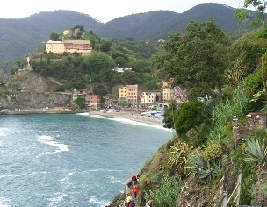

**Q-8    In Bootstrap 4, what is flexbox?**

**Ans.**

In Bootstrap 4, flex box is used to control the layout and alignment specification of Bootstrap 4 components. This box makes it easier to design flexible responsive layout structures without using float or positioning attributes.

**EX..**

    <body>

           <div class="container mt-3">

              <h2> Bootstrap 4 Flexbox Auto Margins </h2>

              <div class="d-flex mb-3 bg-secondary">

                  <div class="p-2 mr-auto bg-info">

Flexbox box 1</div>

                  <div class="p-2 bg-warning"> Flex box

2</div>

                   <div class="p-2 bg-primary"> Flex box 3

</div>

              </div>

           </div>

    </body>

**Q-9   How can one create an alert in Bootstrap?**

**Ans.**

<div class="container">

  <h2>Alerts</h2>

  <div class="alert alert-danger">

    <strong>Danger!</strong> This alert box could indicate a dangerous or potentially negative action.

  </div>

</div>

**Output =**

## Alerts

**Danger!** This alert box could indicate a dangerous or potentially negative action.

**Q-10   What is a bootstrap card and how would you create one?**

**Ans.**

           A card is a flexible and extensible content container. It includes options for headers and footers, a wide variety of content, contextual background colors, and powerful display options.

           Add the . card class to a <div> element and inside the <div> element, add another <div> element with the . card-body class to create a basic Bootstrap card.

**Create Card with use of Bootstrap :**

<!DOCTYPE html>

<html lang="en">

<head>

  <title>Bootstrap Example</title>

  <meta charset="utf-8">

  <meta name="viewport" content="width=device-width, initial-scale=1">

  <link rel="stylesheet" href="https://cdn.jsdelivr.net/npm/bootstrap@4.6.2/dist/css/bootstrap.min.css">

  <script src="https://cdn.jsdelivr.net/npm/jquery@3.6.4/dist/jquery.slim.min.js"></script>

  <script src="https://cdn.jsdelivr.net/npm/popper.js@1.16.1/dist/umd/popper.min.js"></script>

  <script src="https://cdn.jsdelivr.net/npm/bootstrap@4.6.2/dist/js/bootstrap.bundle.min.js"></script>

</head>

<body>

<div class="container">

  <h2 class="text-uppercase text-warning">Card With Use Of Bootstrap</h2>

  <div class="card text-center" style="width:500px">

    <img class="card-img-top" src="https://encrypted-tbn0.gstatic.com/images?q=tbn:ANd9GcTbQAwdqAJY4xht3rg6hbw_81ijK2TdmCjbIQ&usqp=CAU" alt="Card image" style="width:100%">

    <div class="card-body">

      <h4 class="card-title">Person Name</h4>

      <p class="card-text">Information about my degree and knowledge </p>

      <a href="#" class="btn btn-info">Click Here</a>

    </div>

  </div>

</div>

</body>

</html>

